Newton's rings

Aims

- To measure the wavelength of sodium light using the method of Newton's rings.
- To gain familiarity with using a Vernier microscope.

Introduction
Light source
Microscope
Reflecting
slide, A
Lens, L
Glass
slide, B
Centre
line, C
Figure 1: Apparatus

In this experiment the physical property of interference of light will be used to determine the wavelength,, of a light source. The interference fringe system here is a pattern of concentric circles, the diameter of which you will measure with a travelling microscope (which has a Vernier scale). If a clean convex lens is placed on a clean glass slide (optically flat) and viewed in monochromatic light, a series of rings may be seen around the point of contact between the lens and the slide. These rings are known as Newton's rings and they arise from the interference of light reflected from the glass surfaces at the air film between the lens and the slide. The experimental set-up is shown in figure 1.

Part 1: Tutorial Question (10 mins)

The lens-makers equation for a thin lens is given as:

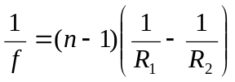. [1]

1.1 Assuming that the refractive index of the lens is 1.5 and the focal length of the lens is 100 cm, calculate the radius of curvature of each of the sides of a biconvex lens.

Part 2: Taking data to measure the wavelength of the sodium light (20 mins)

In this part of the experiment you will measure the diameter of six rings using the Vernier scale on the travelling microscope, and then use this data to determine the wavelength in Part 3.

- Clean the lens and the glass slides with lens tissue and setup the apparatus as shown in Figure 1.

The light from the sodium lamp is partially reflected downwards by a glass slide. The beams reflected from the lens,, and the glass slide  go through the slide to the microscope.

  - Explain why there will be an interference pattern produced and why there is a dark spot at the centre?

- Look for the interference rings with the naked eye – it is easiest to spot these from a height and changing your viewing angle. You may need to manoeuvre the reflecting slide until you can clearly view the rings.

- Focus the microscope on the fringes and align the cross-hair tangential to the central dark spot.

    - Measure the diameters of at least six dark rings by setting the cross-hair on one side of a series of rings, reading the positions and then moving the microscope to the other side of the corresponding rings.

Hints:
- You could start measuring the position of the 12th ring, proceeding to the 10th, 8th, etc. and then moving across to the other side of the central ring until you have measured the 12th ring again.
- Use the magnifying glass provided to read the Vernier scale precisely. To remind yourself how to use the Vernier scale refer back to the Air Wedge experiment.

Part 3: Analysis (20 mins)

The radius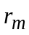, of the 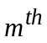 ring is given by

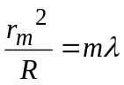 [2]

where R is the radius of curvature of the lens.

(The derivation of this equation is provided, for interest, in the appendix.)

  - Draw a graph of 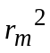 against the ring number (a.k.a. order number of the fringe) m.

3.2 Find an expression for the gradient of this graph.

3.3 Hence calculate the value of, using the value of R stated and the gradient of the graph.

3.4 Compare your result with the accepted value for sodium light of 589nm.

Part 4: Deriving equation for destructive interference (Optional)

  - Work through the derivation shown in the appendix to ensure you can also deduce equation 2.

Further work

The following questions are related to the topic covered by this experimental tutorial.

L65 and L66
Appendix

Let  be the radius of curvature of the lower surface of the lens. Let be the radius of the dark ring, to be measured with the microscope.
t
C
P
r_{m}
Figure 5: Measuring thickness, t.
Q
Let the corresponding thickness of the air gap at the point  be. (See figure 5.)

The path difference between the beams reflected at  and is approximately 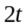 (for vertical viewing, at small radius).

From geometry (refer to figure 6),

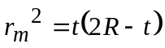 [3]

If is small, we can neglect terms the size of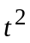. This gives,

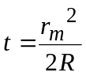 [4]
Figure 6: Determining r_{m}.
r_{m}
r_{m}
2R-t
t

Hence the path difference is

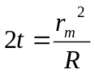 [5]

Now the phase of the wave reflected at is changed by 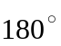 on reflection. If there is also a path difference of 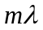 due to the air gap, the two beams will enter the microscope out of phase and hence cancel (destructive interference). This is the condition that will hold at a dark ring. Therefore,

Note that the condition for constructive interference – bright fringe – gives

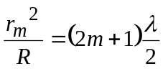 [6]

Demonstrators' Answers, Hints, Marking Scheme and Equipment List
Marking Scheme
Section | Mark
1.1 | 1
2.1 | 1
2.2 | 1
3.1 | 2
3.2 | 1
3.3 | 1
3.4 | 1
Discretionary mark | 2
TOTAL | 10

Answers
1.1 100 cm, R1=-R2 for a bi-convex lens, where –ve sign indicates opposite curvature.

2.1 There is an interference pattern produced because of a path difference between coherent light. The light beam reflected from the glass plate will experience a phase shift of π radians (180 degrees) but the one reflected from the inner lens surfaces won’t. The path length due to the thin wedge causes an additional difference in phase, meaning that there will be destructive interference at a path difference of integer number of wavelengths. This also explains why there is a dark spot in the centre of the rings produced.

  - The gradient of the graph is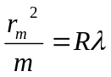.

  - The wavelength obtained should be close to 589nm.

Fringe Order m | Reading 1(m) | Reading 2 (m) | Diameter D (m) | Radius R (m) | Radius² R² (m) | Radius of curvature of convex lens (m) | Wavelength λ (m)
0 | 0.03435 | 0.03469 | 0.00034 | 0.00017 | 2.89E-08 | 0.3 | 5.92E-07
2 | 0.03399 | 0.03515 | 0.00116 | 0.00058 | 3.364E-07
4 | 0.03371 | 0.0354 | 0.00169 | 0.00085 | 7.14E-07
6 | 0.03351 | 0.03557 | 0.00206 | 0.00103 | 1.061E-06
8 | 0.03334 | 0.03571 | 0.00237 | 0.00119 | 1.404E-06
10 | 0.0332 | 0.03589 | 0.00269 | 0.00135 | 1.809E-06
12 | 0.03307 | 0.036 | 0.00293 | 0.00147 | 2.146E-06
14 | 0.03295 | 0.0361 | 0.00315 | 0.00158 | 2.481E-06

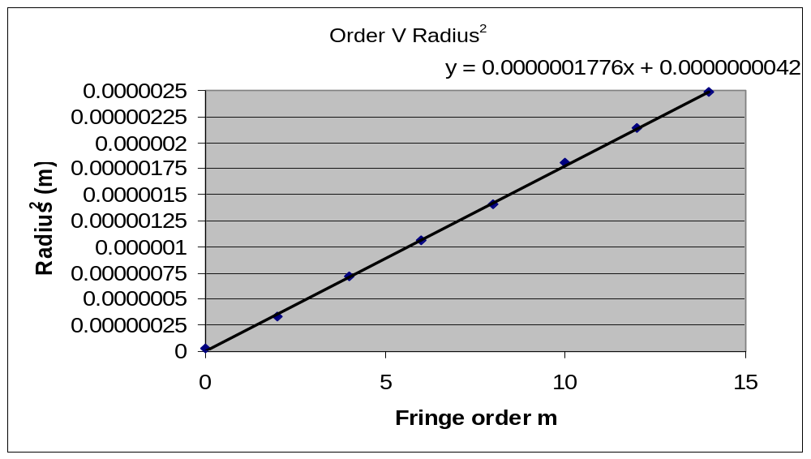

Equipment List

Travelling microscope with magnifying arm detached.
Magnifying torch
Biconvex lens of known focal length – e.g. 100cm. Must be specified to student.
Glass slide
Sodium light
Optical track
2 x saddles with lens and mirror holders
Mirror
Lamp on stand
Screen with triangular hole

